Part2: Penetration Testing foundations:
- What are the common jumping strategies necessary for crafting a successful memory exploit? Could you elaborate on the significance of back jumps, forward jumps, long jumps, short jumps, and other types of jumps in this context? Please explain in detail.
The answer:
The goal
In most memory exploits you first redirect EIP (e.g., overwrite a return address/SEH) and then you must move execution from wherever you land to where your real payload sits. Jumps are how you bridge that gap under tight space and bad-char constraints.

Core jump types & where they’re used
1) Short (relative) jump
What: 2-byte instruction with a ±128-byte range.
Why is it critical: Tiny, rarely hits bad characters, perfect when you only control a very small staging area (SEH overwrites, tiny stack windows).

Typical uses:

-Skip over unsafe bytes or a handler pointer.
-Hop from a tiny first stage to a spot where you placed a larger second stage (decoder, long jump, or full shellcode).

2) Long/Near (relative) jump
What: 5-byte instruction with a 32-bit displacement (very far reach).
Why: When your shellcode is far away (e.g., in a different part of the buffer, heap, or environment).
Typical uses: Second stage after a short jump—once you’ve reached a safe area, you use a long jump to travel the longer distance to the main payload.

3) Forward jump
What: Positive displacement to a later address.
Why: To skip ahead past restricted bytes/SEH records or a small stub and land on your bigger payload that you placed after the overwrite area.
Typical uses: SEH exploitation (put a short forward jump in nSEH to land after SEH), staged payloads (stub → main blob).

4) Backward (back) jump

What: Negative displacement to an earlier address.
Why: When your main shellcode is before the place you hijack control (common in stack overflows where EIP is overwritten near the end of the buffer).
Typical uses: Land at EIP, then jump back into your NOP sled / decoder / main shellcode at the start of the buffer.

5) Indirect register/memory jump (e.g., jmp eax, call esp)
What: Transfer control to the address held in a register or memory location.
Why: Invaluable when you can influence a register (ESP/EAX/EDI, etc.) or when you can only overwrite EIP with a pointer to a gadget like jmp esp in a non-ASLR module.
Typical uses: Classic “jmp esp” landing, or using push <addr>; ret/call [mem] gadgets to reach controlled memory. Also used for stack pivots (moving ESP to your buffer) in ROP scenarios.

6) Conditional jumps (JZ/JNZ/… used as “pseudo-unconditional”)
What: Short conditional branches.
Why: Sometimes the opcode bytes for an unconditional short jump are bad; you can make a condition always true (via a prior test/cmp) and use a conditional short jump instead.
Typical uses: Bad-char evasion in tight encoders/decoders or Unicode constraints.

7) Call/Pop (GetPC) technique
What: Use call to push the next address then pop it to get a position-independent pointer.
Why: Lets your stub discover its own location and compute where the payload is, enabling position-independent shellcode.
Typical uses: Encoded payloads/decoders, egg hunters, staged loaders.

8) Multi-stage (short → decoder/aligner → long)
What: Chain of small jumps.
Why: Real exploits often need a tiny first stage (fits strict space and bad-char limits) which then sets registers/alignment and performs a longer jump to the final shellcode.

Typical uses: SEH exploits, Unicode/“Venetian” encodings, tight buffer windows.

9) ROP/stack-pivot “jumps” (ret-based control flow)
What: Not literal jmp, but gadgets like xchg esp, eax; ret or add esp, N; ret that move the stack to a controlled area.
Why: When DEP/ASLR force you into ROP, these gadgets act like jumps to your ROP chain or to RWX memory you control.
Typical uses: Modern Windows/Linux targets, DEP bypass.

-How these pieces fit in real exploits
SEH pattern: nSEH = short forward jump → skip SEH pointer → land in a safe area → long jump or indirect jmp reg to main shellcode (often back into the start of the buffer).

Classic stack overflow: Overwrite EIP with address of jmp esp → land at top of your buffer → maybe a short back jump into a NOP sled if needed → run decoder → long jump to big payload.

Bad-char/Unicode cases: Use short jumps and conditional-as-unconditional tricks; chain stages to avoid forbidden bytes; sometimes “Venetian” alignment to keep execution on valid boundaries.

-Practical takeaways
Short jump = space/bad-char friendly; use it to navigate tiny windows.

Long jump = distance; use it once you’ve reached a safe staging area.

Back vs forward is about where your main payload lives relative to the EIP landing.

Indirect/register jumps and stack pivots are your escape hatches when absolute addresses are limited, or defenses are on.
Staging (short → align/decoder → long) is the workhorse pattern for reliable exploits.
………………………
Part3: Target #1 Exploit-Me server:

- Creating custom network scanning scripts and efficiently executing them to scan the target in order to identify vulnerable services on it using python or bash scripting.
The answer:
This is the python script:
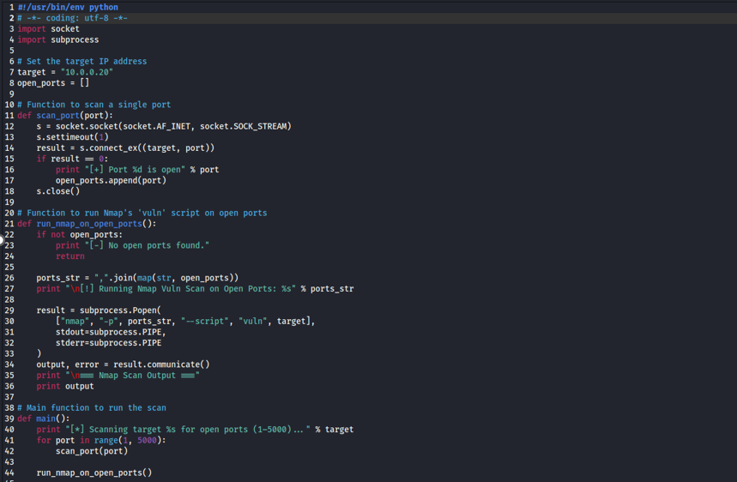
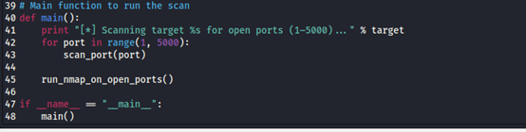
We run it:
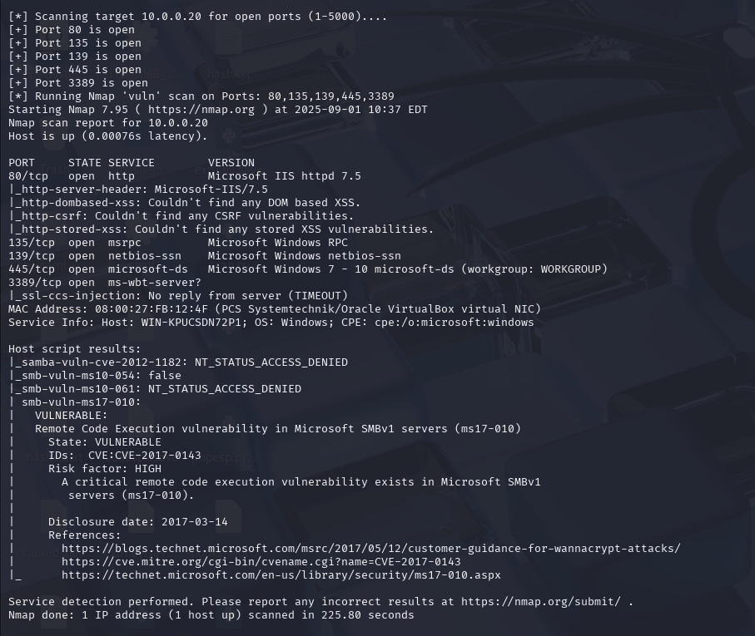

…….
- Use fuzzers such as Spike Fuzzer or any equivalent tool, along with debuggers like Immunity Debugger, to analyze software running in memory and successfully fuzz it to determine ways to crash the software
The answer:

I created a SPIKE script vuln.spk:
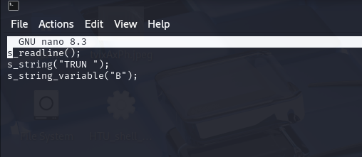
I executed the fuzzer:
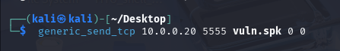

-While the fuzzer was running, Immunity showed the incoming payload on the stack as long sequences (e.g., AAAA…), confirming my input was reaching the process.

-The debugger broke into the process when the payload grew large, showing memory corruption around the TRUN handler (ASCII view full of As near the return path).

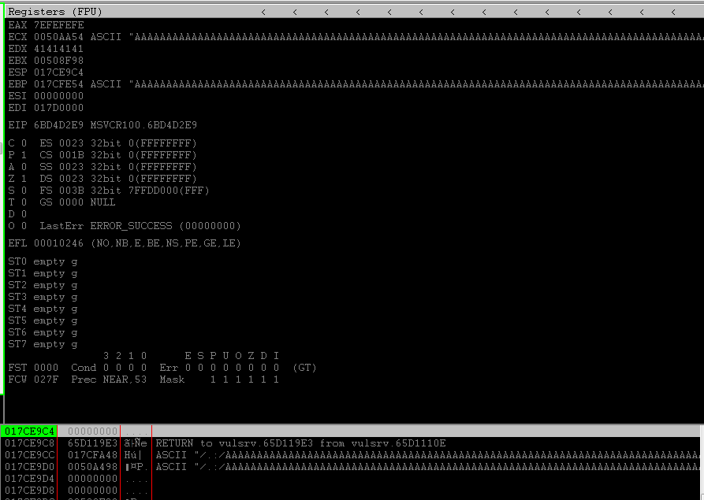
…………..

- Use the NASM tool to create a short jump for 10 bytes and a back long jump for 4000 bytes.
The answer:
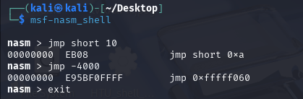

-Short Jump (EB 0A): Moves execution forward 10 bytes from the current instruction pointer. Short jumps are typically used when the target is close by, often within small shellcode stubs or to skip over a few bytes of code.

-Long/Near Jump (E9 …): Moves execution backward 4000 bytes. This is useful in exploit development for looping back to a larger payload stored earlier in memory, especially when space after the instruction is limited.

- Create the full Python script to exploit this service (port 5555) using the memory corruption techniques JMP ESP. Explain each step inside the script using comments, detailing why each line of code is included using Auth as entry point. You can use the provided python template as starting point. Provide proof that your script exploits the target system using a message box for the first exploit and then using shellcode to create a payload for either a bind shell or a reverse shell for the second exploit. Utilize MSFvenom to generate the necessary payload as Python bytecode.
The answer:
This Python script is the first stage of the exploit before adding shellcode; it connects to the vulnerable service on 10.0.0.20:5555, sends the command Auth followed by 1040 “A” characters (the exact offset we previously calculated using a cyclic pattern), then overwrites EIP with the address of a JMP ESP instruction (0x6DA5C86D, written in little endian as \x6D\xC8\xA5\x6D), and finally pads the buffer with “C” characters to keep the length consistent; when executed and observed in Immunity Debugger, the program crashes as expected and we clearly see that EIP has been overwritten with the JMP ESP address, confirming that we successfully control program execution and can redirect the flow to our payload placed at ESP, with no SEH interference—this proves the exploit path works, and the next step will be to insert a NOP sled and shellcode after EIP to achieve code execution.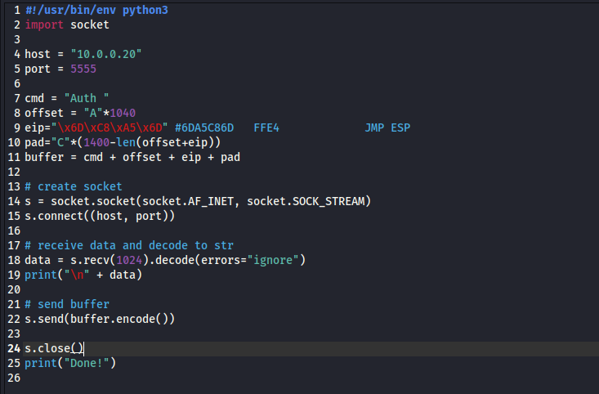

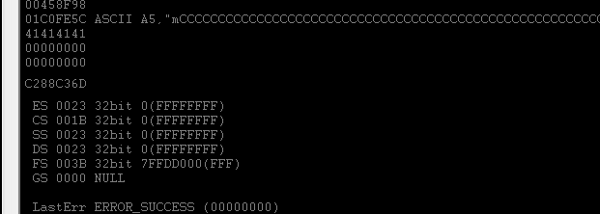

- use shellcode for the message box:
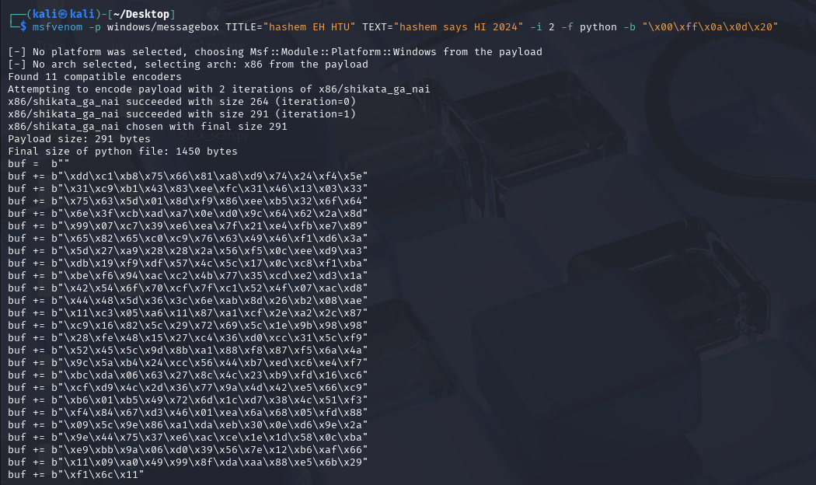
This is the script:
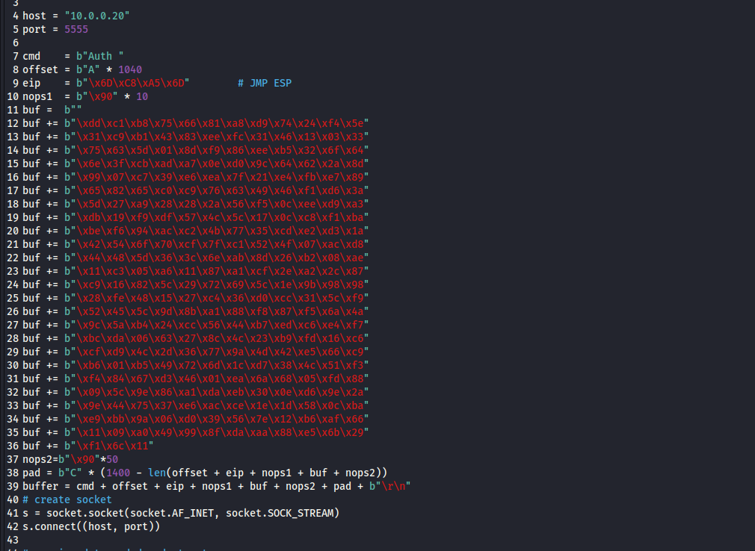

This is the message box :
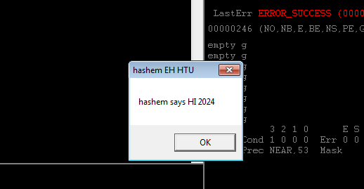

-use shellcode for shell bind:
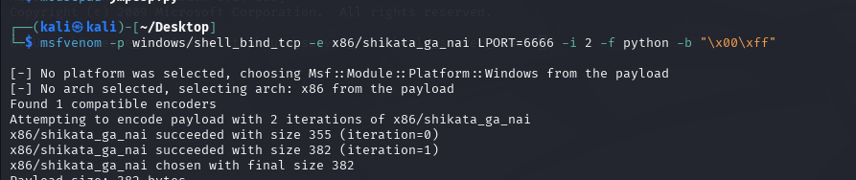
This is the script:
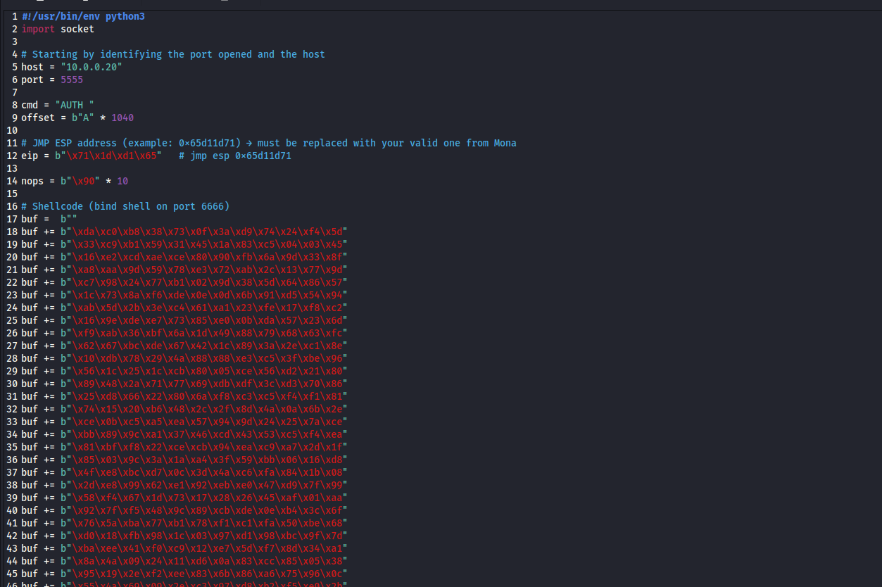
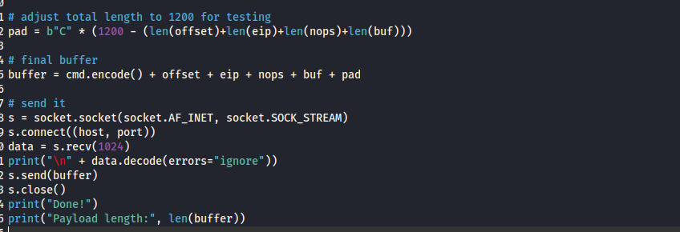

When we run it we notice there is new port open 6666:
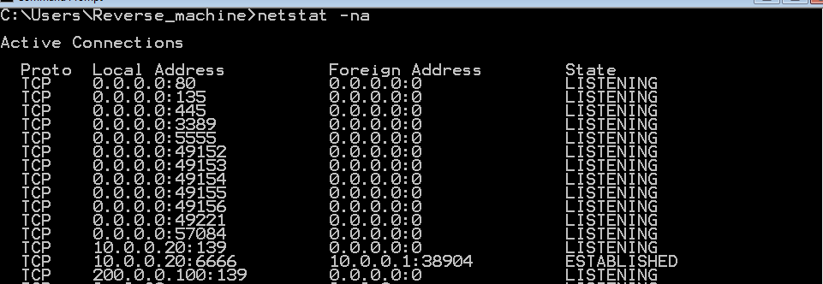
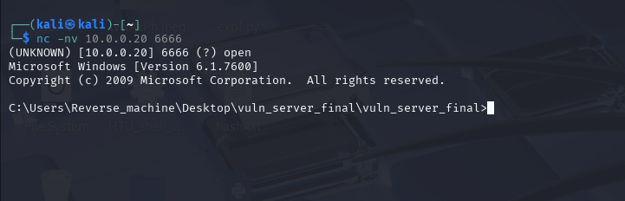

Note:
Using mona gives us the whole pattern or position on where the Esp is found and ofc this is done using the jmp command, this will make the process of testing faster and easier with the help of this tool.
! mona jmp -r esp (this give you the address of the jmp esp.)
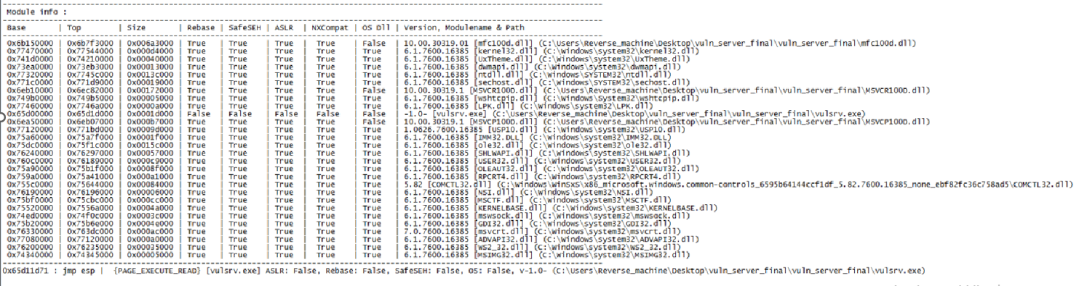

The jmp esp: \x71\x1d\xd1\x65

E) Load the backdoor you created through the msfconsole multi-handler, then exploit the target machine
The answer:
In this step, I loaded the backdoor shell I had generated into msfconsole using the multi/handler module. I set the payload to windows/shell_bind_tcp, then configured the LPORT to 6666 and the RHOST to the target machine (10.0.0.20). After confirming the options, I executed the exploit with run. The handler successfully connected back to the vulnerable target, opening a command shell session. To verify that the exploit worked, I ran the command whoami inside the shell. A the output confirmed that I had code execution on the target machine as the user reverse_machine. This proves that the bind shell exploit succeeded and gave me remote access to the target system. Then I use background
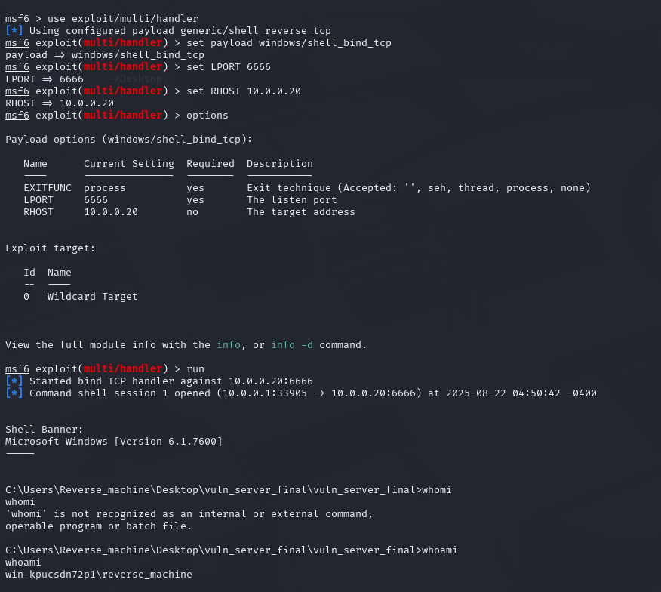

And I use background sessions:
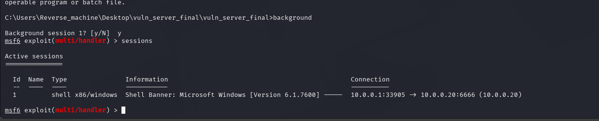

…….
Part 3) target DPSR server
- Scan the target #2 to find open ports after creating a route to the target using the session created in the last part as the gateway for this route, which is required for pivoting.
The answer:
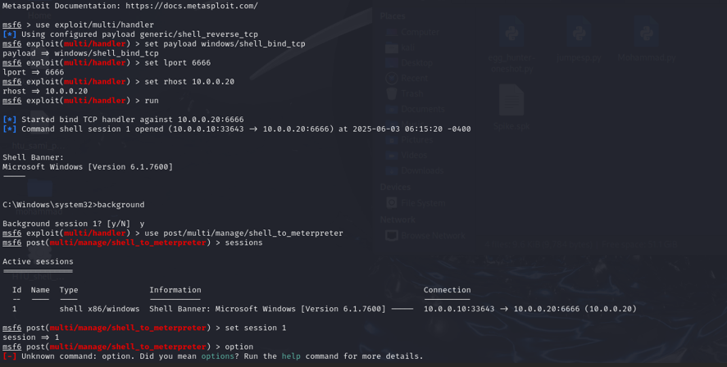
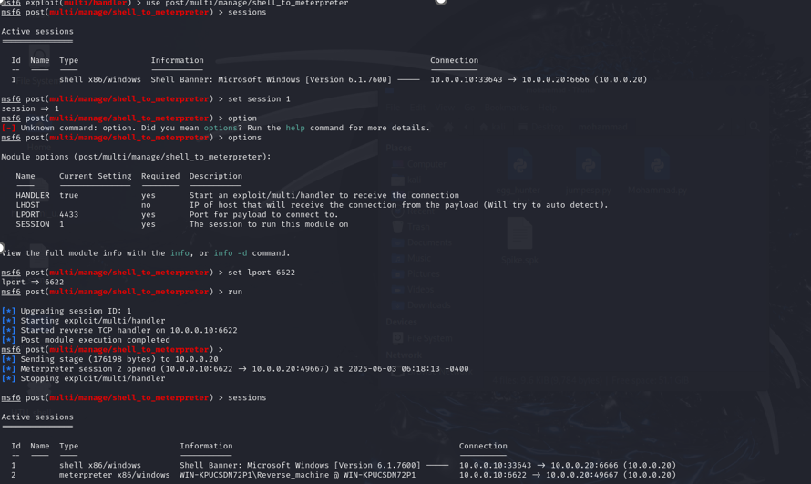
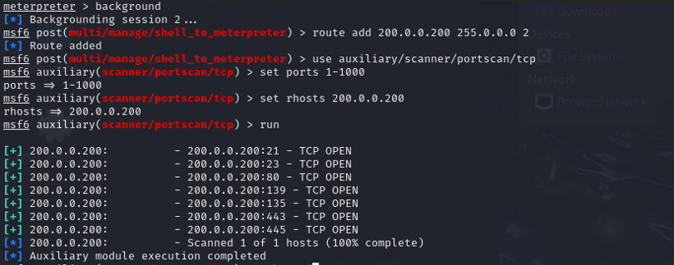

- Create as many tunnels (pivoting points) as needed to reach and attack the DPSR server. These pivoting points could include FTP, HTTP, etc.
The answer:
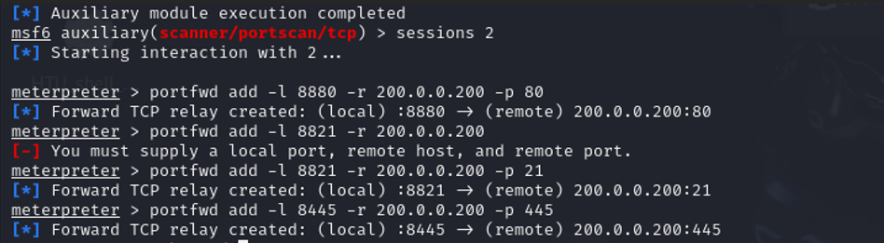
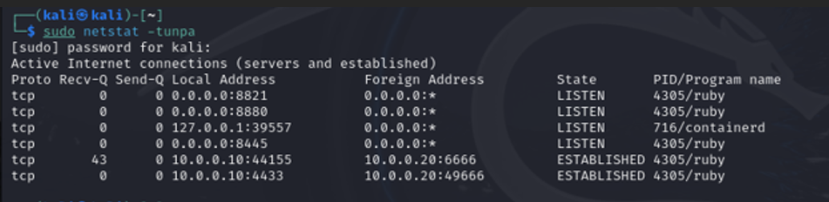
……….
- Identify a SQL Injection vulnerability, exploit it, and extract the database name
The answer:
Username: Admin’#
Password: 12345
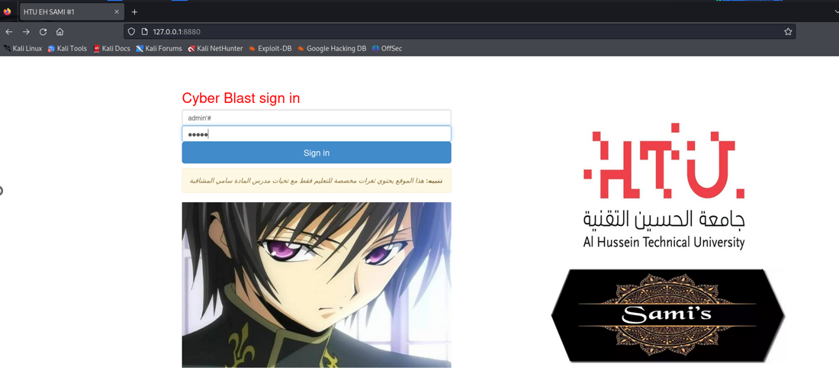

The image shows that I manually performed a SQL injection attack to successfully extract the database name.

…………………………………….
D)CTF flags:
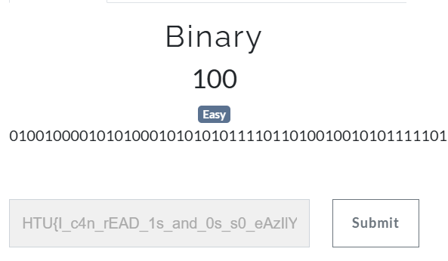
https://gchq.github.io/CyberChef/
……..
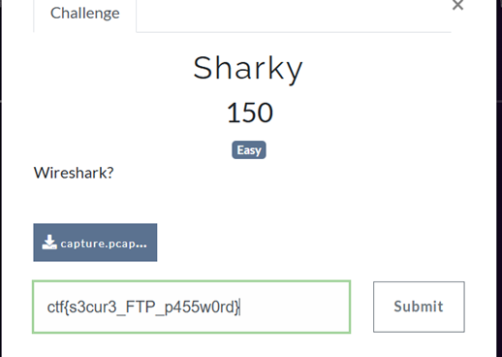
………..
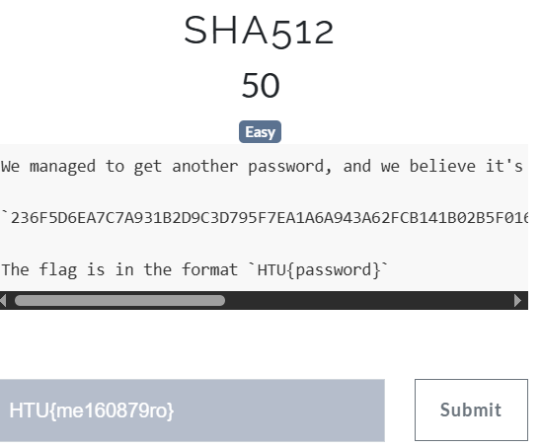

https://crackstation.net/
……….

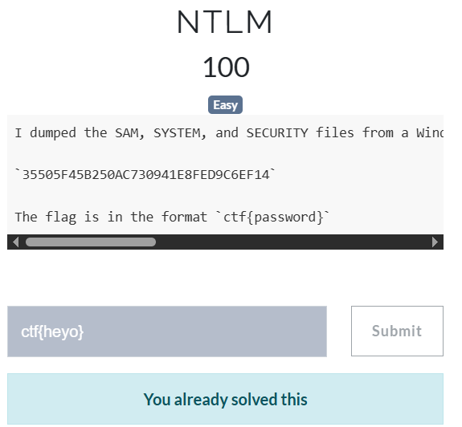
https://crackstation.net/
…………..
Shangrilla
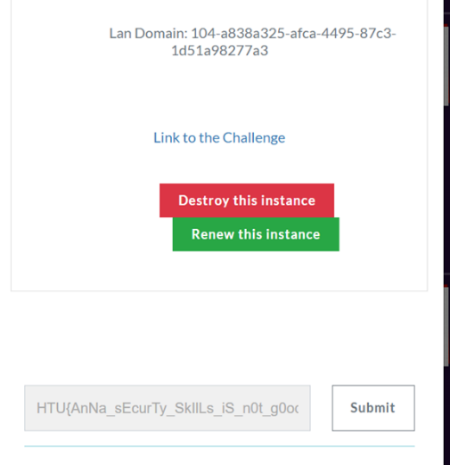
………
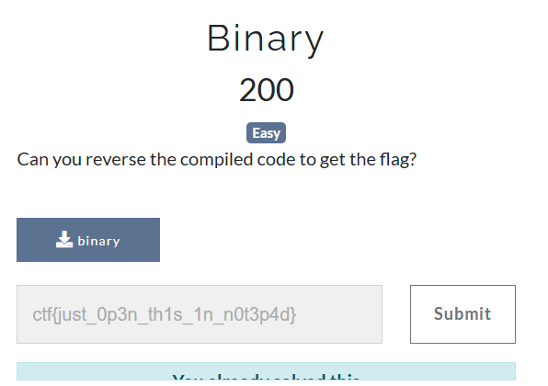
https://dogbolt.org/
…………
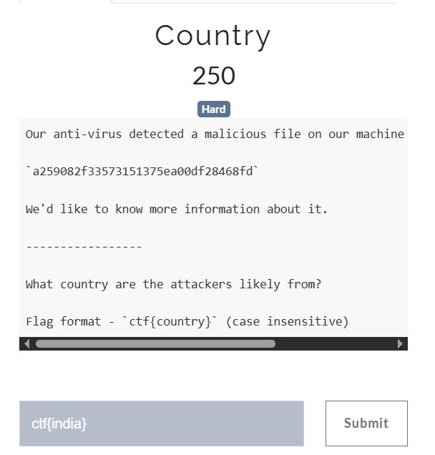
https://hybrid-analysis.com/
https://whois.domaintools.com/ttgholidays.com

………..

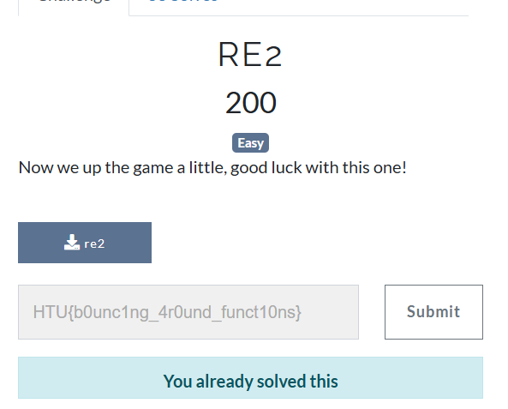

https://dogbolt.org/

……….
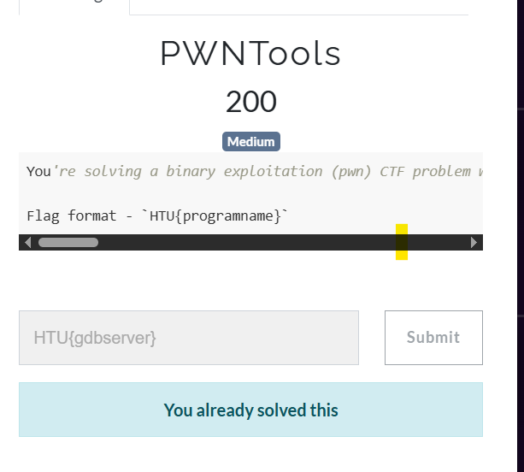

………

EvilHTU :
